A Complete SEO Site Audit Template, Guide, Worksheet with Actionable Tips

SEO Website Audit Template 2019
Use this worksheet to benchmark, analyze your current rankings in Google
SECTION 1. Current Ranking Report
Benchmark your current rankings. This can be done either manually searching in Google for your keywords or use a tool like Ahref, SEM Rush, Moz combined with your Google Analytics, Google search console data
My web pages: Keywords: Currently ranking in position:
www/iphonex.com/256gb-black Buy iPhone 10 256GB Black Number 3, 1st page
___________________________________ __________________________________ ___________________________________
___________________________________ __________________________________ ___________________________________
___________________________________ __________________________________ ___________________________________
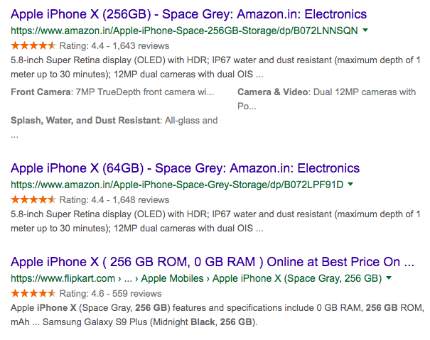
TIP: 👍
You have to do SEO for every page, search for relevant keywords for each page and audit where your pages are ranking.
My objective is to:
Increase rankings for: Keywords: Position, Timeline:
www/iphonex.com/256gb-black Buy iPhone 10 256GB Black Number 1 in the next 3 months
___________________________________ __________________________________ ___________________________________
___________________________________ __________________________________ ___________________________________
___________________________________ __________________________________ ___________________________________

SECTION 2. Google Search Console & Google Analytics
Search Console is a free by Google. The tool and reports help you measure your site's Search traffic and performance, fix issues, and make your site shine in Google Search results. https://search.google.com/search-console

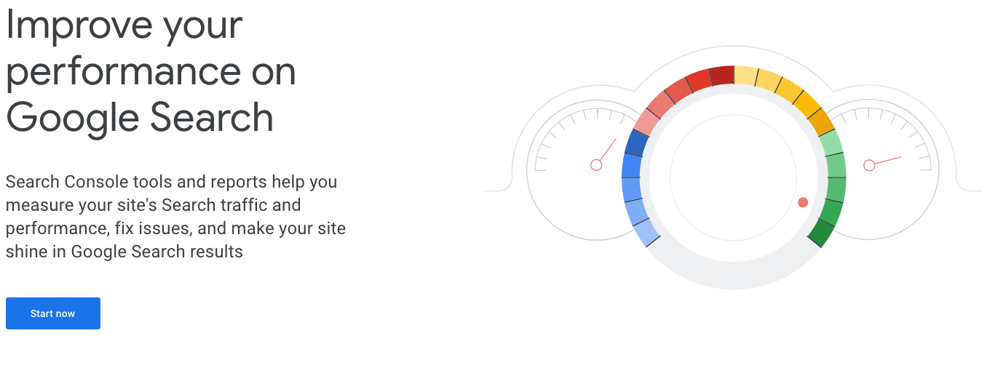

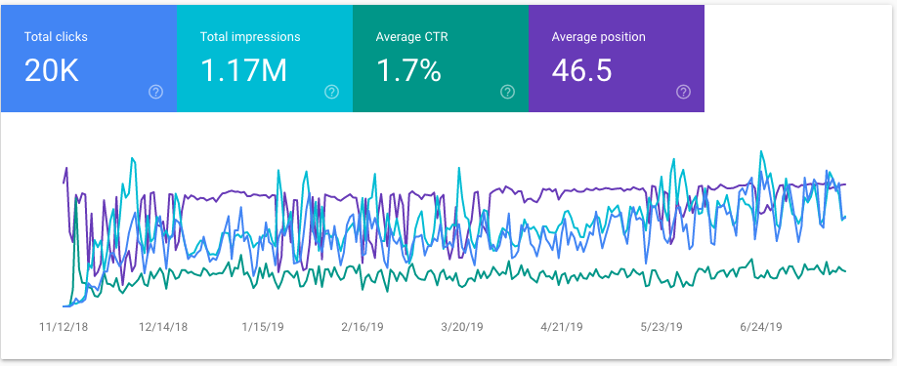

TIP: 👍
- If you haven’t signed up for Google Search Console or Google analytics, do it now. It’s a free tool and a must for any business
- Check URL inspect - The HTTP response should be 200 OK

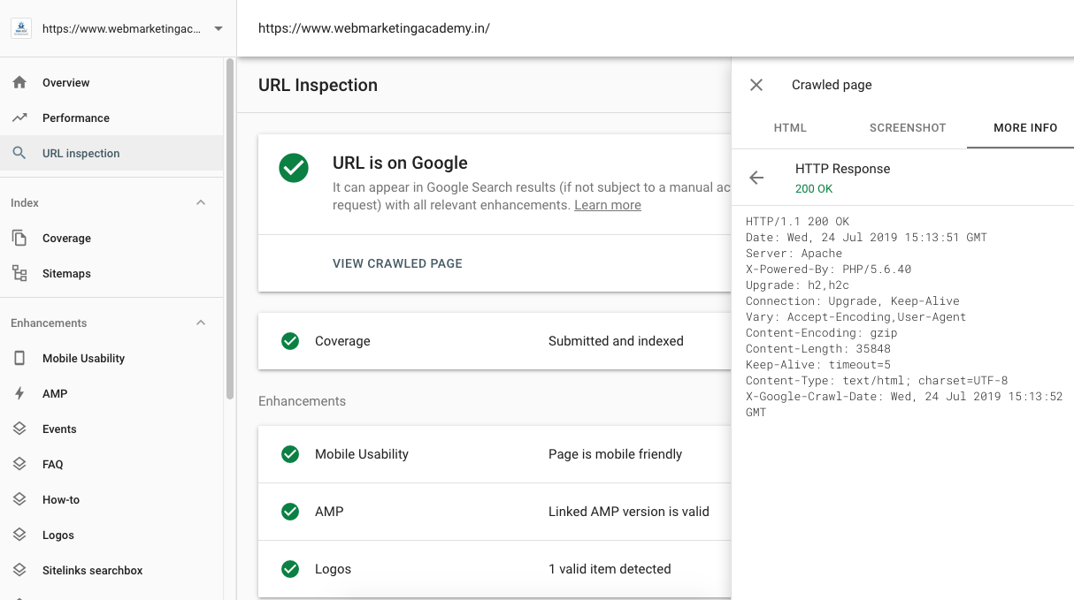

Sign up for Google Analytics: https://analytics.google.com
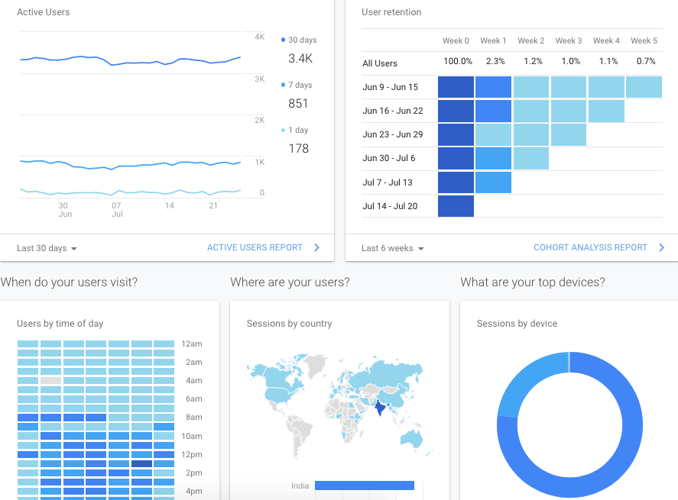
ACTION ITEM: ✓
- Sign up with Google search console
- Sign up with Google analytics
- Look for manual action, security issues, Index coverage

SECTION 3. Page Speed
If you run a business online, your website speed is crucial. It gives a positive experience for a user, especially in mobile
Average load time: Less than 3 seconds
Here’s how to find your web page load time: Google page speed Insights: https://developers.google.com/speed/pagespeed/insights/ A score of 90-100 will be ideal
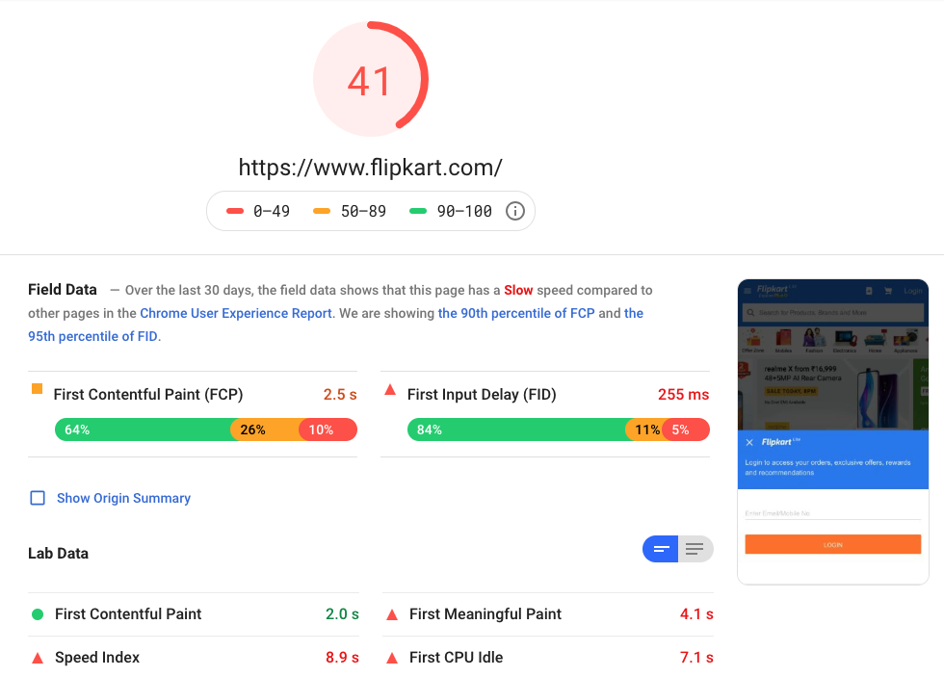

Think with Google has an awesome free tool called Test my site, which gives site speed, benchmark against your competitors, revenu impact calculator: https://www.thinkwithgoogle.com/feature/testmysite

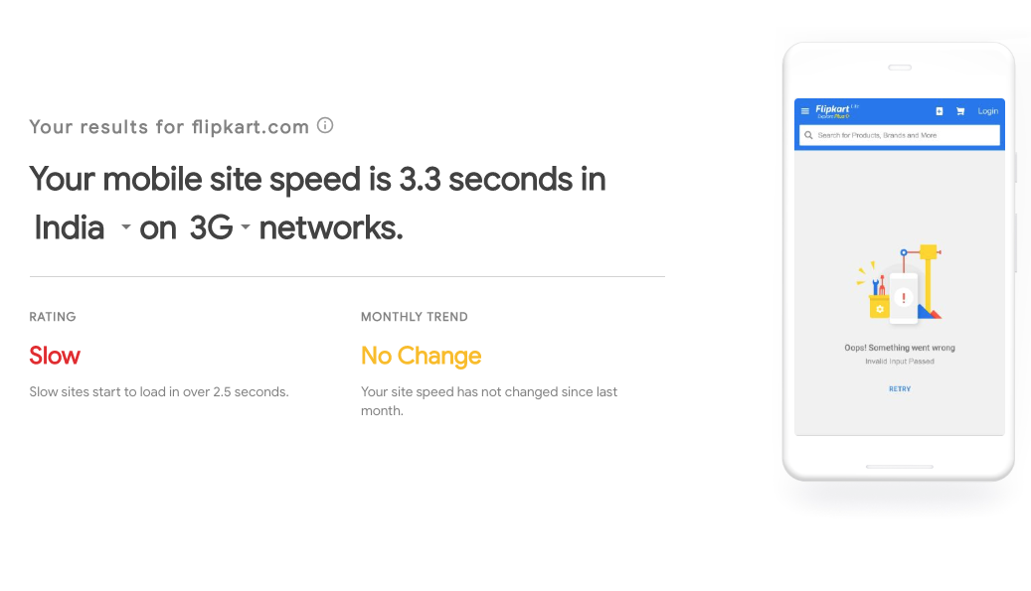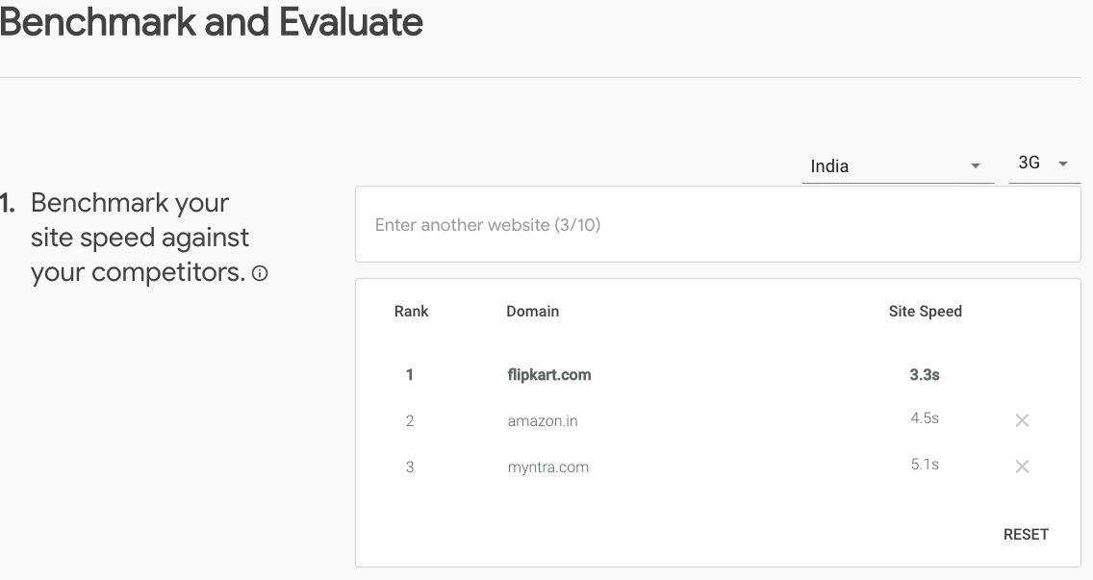

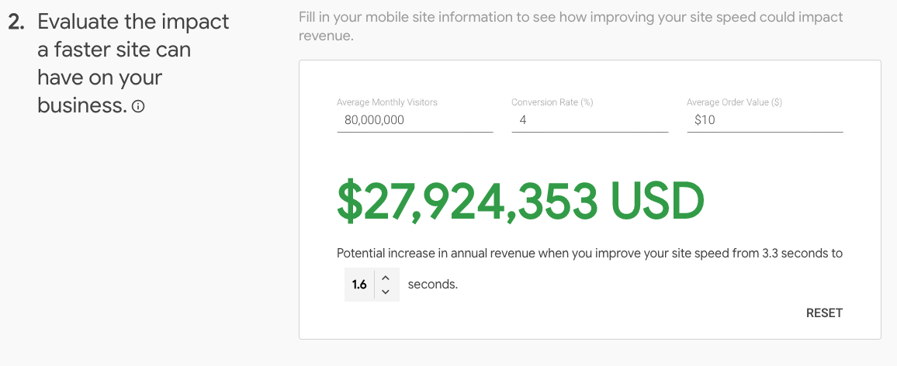
TIP: 👍
If you have a wordpress website, here are some of the plug-ins which can fix the slow speed. https://wordpress.org/plugins/wp-smushit/ https://wordpress.org/plugins/wp-fastest-cache

ACTION ITEM: ✓
- Check your website in page speed insight, test my site
- Install word press plugin. Download suggestions
- Check with the IT/Developer team. Hand over suggestions to the team
Resources: All about page speed: https://developers.google.com/speed/docs/insights/v5/about

AMP (Accelerated Mobile Pages)
AMP is a web component framework and a website publishing technology developed by Google which has the mission to "provide a user-first format for web content.
AMP are web pages designed to load faster in Mobile. It loads any AMP instantly in any browser.
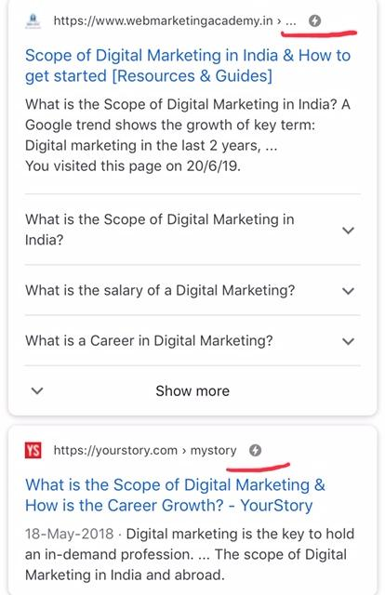
TIP: 👍
If you have a wordpress website, here is a plug-in for AMP https://wordpress.org/plugins/accelerated-mobile-pages/ A free complete course on AMP: https://www.youtube.com/playlist?list=PLXTOW_XMsIDS45GB-eBV5s_M9EGIXMjI_
ACTION ITEM: ✓
- Validate your AMP page in Google search console
- Install word press plugin. Resources: All about AMP: https://amp.dev/
SECTION 4. HTTPS
Every website should be HTTPS secured. If you haven’t secured it yet, now is the time. You have to purchase a SSL certificate and connect your website. The hosting companies can help.
When you switch your http to https, Google considers the new version https as a new website. Before switching you have to do a redirect. A 301 redirect keeping both the version of your website, http and https
TIP: 👍
- This wordpress plug in does it seamlessly: https://wordpress.org/plugins/really-simple-ssl/
- Once you moved, you have to submit & verify your https version as a new website in Google Search Console and Google Analytics
- Other wordpress SEO plug-ins to install - All in SEO or Yoast
ACTION ITEM: ✓
- Talk to your technical team/developer
- Install word press plugin.
- Get an SSL certificate from the hosting provider
- Submit & verify https in Google search console & Google analytics
Resources: HTTPS - A Beginners guide: https://www.wpbeginner.com/wp-tutorials/how-to-add-ssl-and-https-in-wordpress/
SECTION 5. Indexed pages
Google Index: The number of pages indexed by Google:
e.g. 1,36,00,000 out of 10,00,00,000 pages have been indexed by Google
This indicates how many web pages Google has discovered and stored in their database. If you have 10,00,00,000 pages and Google shows 1,36,00,000 pages, then there is a problem.
Here is how to find out the number of pages indexed by Google: site:https://www.flipkart.com do a Google search with site:www.yourwebsite.com (replace yourwebsite.com with your website)
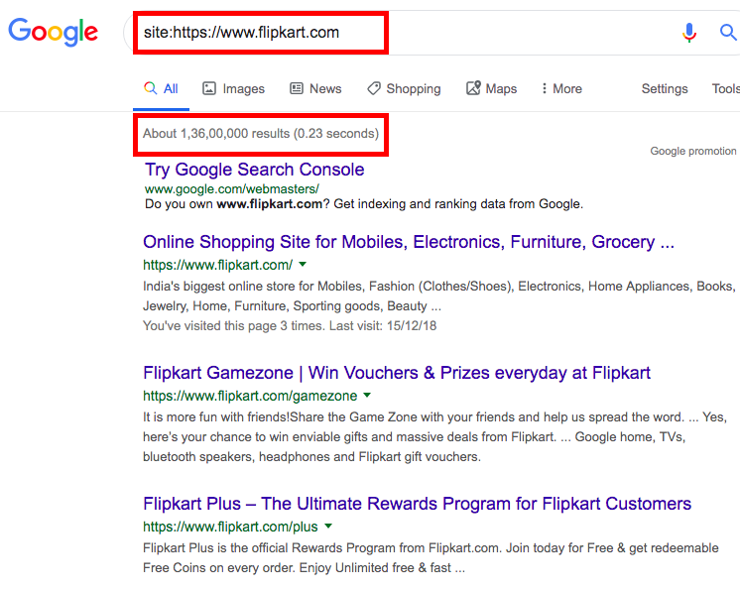

The number of pages indexed by Google for Flipkart

ACTION ITEM: ✓
- Check with your designer/developer the total number of pages on your website
- Check for robot.txt files or no index tags (you need a technical expert to look into it)
- Learn more about robot.txt an opportunity for me to add some technical skills
Resources: All about robot.txt: A Google developers guide

SECTION 6. Keyword research
Keywords, key phrases is one of the most important steps in SEO
This is the first step in on-page SEO. Keyword research is done for every page. A page can have 2-3 main keywords depending upon the topic of the page. It should be relevant, long tail, and specific (3 or more keywords. Example: “Buy iPhone X 256 GB Black”
Watch this video on How to do keyword research in 2019: https://www.youtube.com/watch?v=HpPPzYl_ap0
Here is a sample keyword research sheet:
Page | Friends & family | Google search | Google suggest | Google trends | Personalized search | Google keyword planner
www.flipkart.com/apple-iphone-6s-gold-32-gb | iPhone 6  iPhone 6s | iPhone 6  iPhone 6s | iPhone 6s rose gold | iPhone 6s | Iphone 6S under Rs 40,000 | Buy iphone 6s rose gold online
Google suggest:
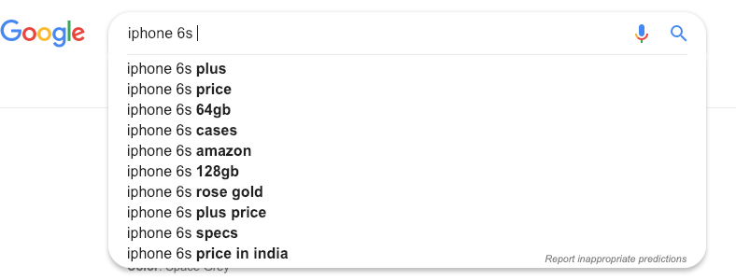
TIP: 👍
- Each page can be optimized only for 2-3 keywords/phrases
- Do a voice search in your mobile in Google assistant
- Google keyword planner: Look for high search volume keywords. https://ads.google.com/intl/en_in/home/tools/keyword-planner/
- If you are a local business, use location in your keywords. Example: Dentist near Indira Nagar, Bangalore
ACTION ITEM: ✓
- Do keyword research for all pages
- Finalize 2-3 main keywords for each page
- Validate using Google keyword planner

SECTION 7. Use of keywords in Page title
Add keywords in the Title of page. Each page should have unique title around 65 characters, start the title with your top keyword after the research. Example: “Buy iphone 6s rose gold online at Flipkart”
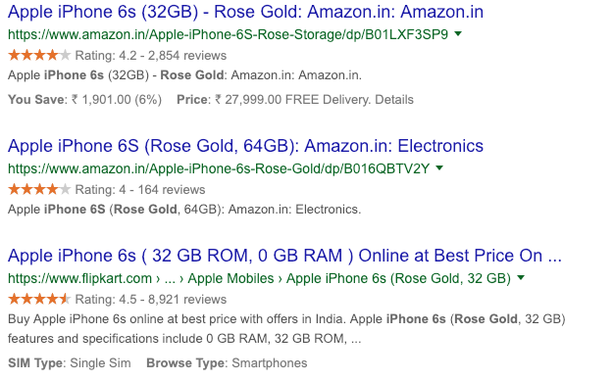Page Title

TIP: 👍
- Utilize all the characters
- Avoid page titles like Welcome to my Home Page
- Avoid keyword stuffing
- The page title should be readable
- Add keywords for all pages. By doing a site:www.flipkart.com you can find all the title of your website
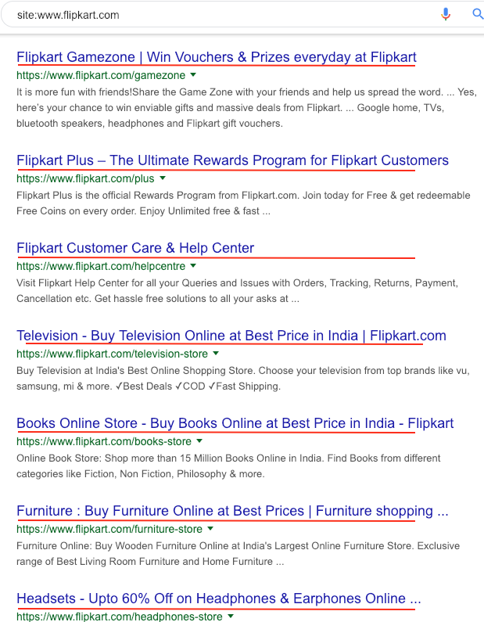

ACTION ITEM: ✓
- Double check all the title. Does it include the keywords?
- Blogs: Is the title of my blog posts relevant?
- Send the updated version for approval/developers
- Install Yoast or All in One SEO wordpress plugin
Here is a sample Title for each page: (Your developer will understand where to add the title) If you are using wordpress, Go to each page and change the title in Yoast or All in One SEO page title section

Page | Final Keywords | Existing Title | Suggested Title
www.flipkart.com/apple-iphone-6s-gold-32-gb | Buy iphone 6s rose gold online | iPhone 6s rose gold 64 GB | Buy iPhone 6s rose gold 64 GB Online at Flipkart

SECTION 8. Meta Description
Meta description is the snippet that you see below the page title when you do a Google search. Make sure you give a good meta description
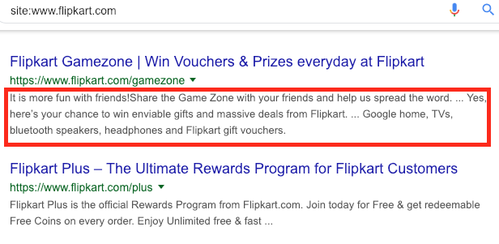
TIP: 👍
- You have 120-250 characters to include in your meta description
- Think of your USP and include the USP’s in your meta description
- Offers, discounts with specific number can help users click and go to the website

ACTION ITEM: ✓
- Check all the meta descriptions including blogs
- Avoid short meta descriptions
- If necessary include numbers, price, discounts

Page | Final Keywords | Existing Title | Suggested Title | Existing description | Suggested description
www.flipkart.com/apple-iphone-6s-gold-32-gb | Buy iphone 6s rose gold online | iPhone 6s rose gold 64 GB | Buy iPhone 6s rose gold 64 GB Online at Flipkart | Buy Apple iPhone 6s online at best price with offers in India. Apple iPhone 6s (Gold, 32 GB) features and specifications include GB RAM, 32 GB ROM | When it comes to elegance and perfection, nothing can stand next to Apple iPhone 6s (Gold, 64GB). Loaded with highly advanced features and eye-catchy details

SECTION 9. URL structure
The url structure is the link, which contains the domain name followed by folder and subfolders
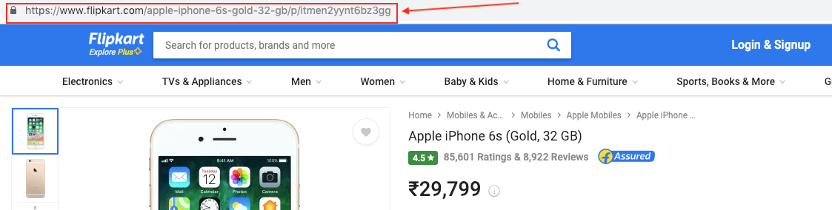

TIP: 👍
- Keep your URL structure simple and easy to understand
- Use hyphens to separate words
- Avoid characters
- All lower case
If your website is old and planning to restructure your URL, don’t just change, Google will consider it as a new page. Before changing the structure, make sure you do a 301 redirect, keeping both the old and new page

ACTION ITEM: ✓
- Check all the URL structure
- Inform the IT team/developers to do a 301 redirect
- Include keywords in the URL

SECTION 10. Header tags (Headings and subheadings)
Use of header tags. H1 is the main heading. H2, h3 sub headings
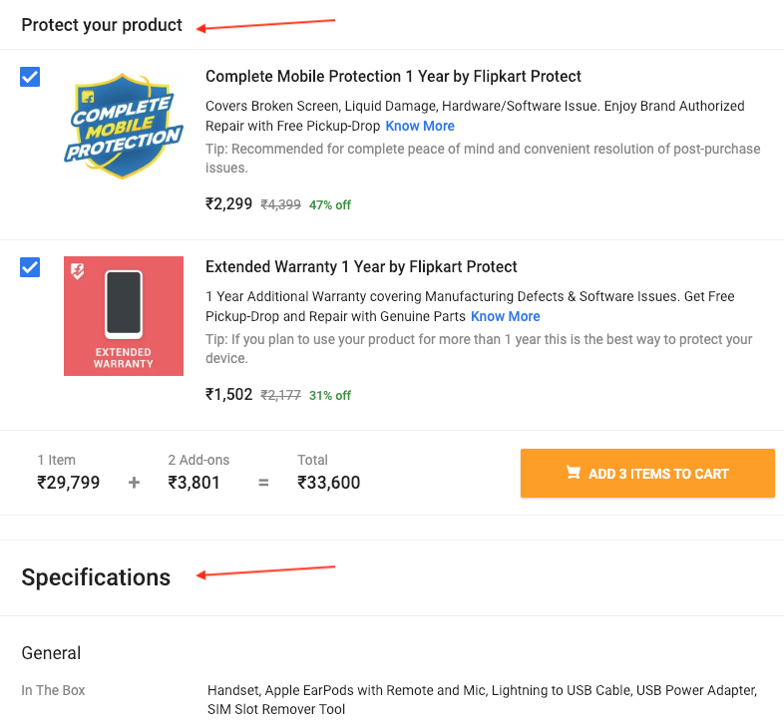
TIP: 👍
- Use one H1 and you can use multiple h2, h3 to organize
- It should help a user understand the topic/theme
ACTION ITEM: ✓
- Check for h1,h2 in all pages
SECTION 11. Content
Content is one of the main factors when it comes to on page SEO. Make sure your content is unique, relevant, useful and meaningful. Include images, videos, Q&A, Reviews . Include keywords, synonyms, FAQ’s in your content
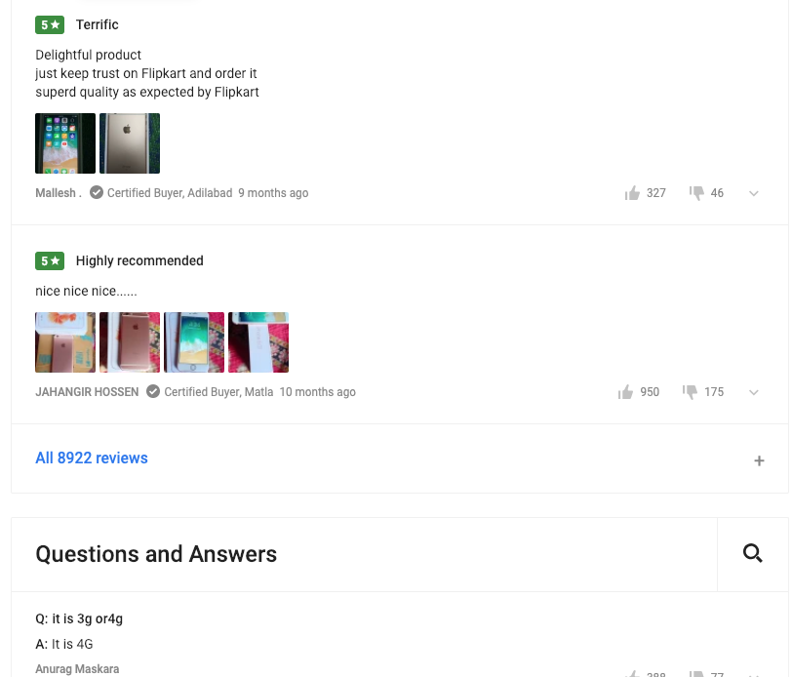
TIP: 👍
- While coming up with content, think about what users would like to see, read, watch
- Important words can be bolded, italic and has a flow with Call to Actions
ACTION ITEM: ✓
- Include CTA’s
SECTION 12. Anchor text
Anchor links or anchor text are links to other pages within your website.
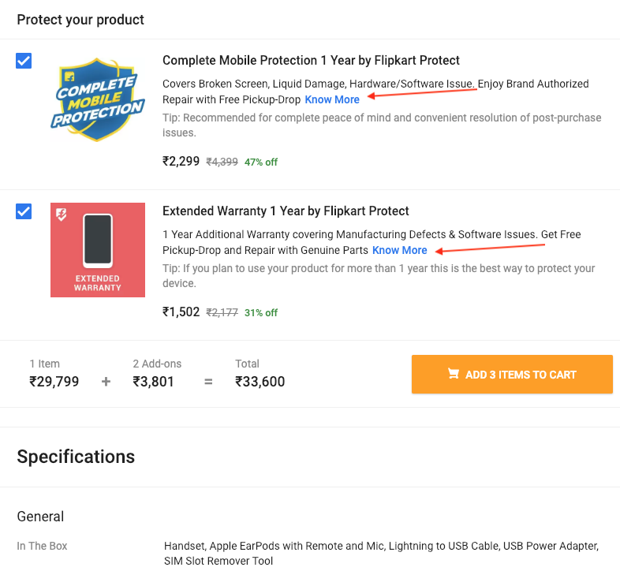
TIP: 👍
- Use anchor links, linking to relevant pages within the website
- Avoid too much links in a given page. You can link your keywords to relevant pages
ACTION ITEM: ✓
- Double check all the page for anchor link opportunities
- Instead of know more, have anchor links like know about iPhone 6
SECTION 13. Optimize Images, PDF’s, PPT’s
Apart from optimizing your text, make sure you optimize your images, videos, PDF’s, PPT’s and other rich media. Use alt text (alternative text) All the steps above is applicable for optimizing your media.
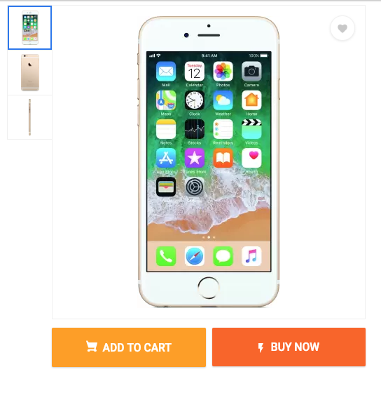
TIP: 👍
- Optimize the files and folders with relevant names
- Add alt tags to all images. Describe the image instead of just one or 2 words
ACTION ITEM: ✓
- Check for alt tags for all images
- Use relevant keywords with descriptive text
SECTION 14. Site Maps
Site maps are like directory to all the pages to your website. Create HTML sitemap for users and XML sitemap for search engines Sample HTML & XML Sitemap:
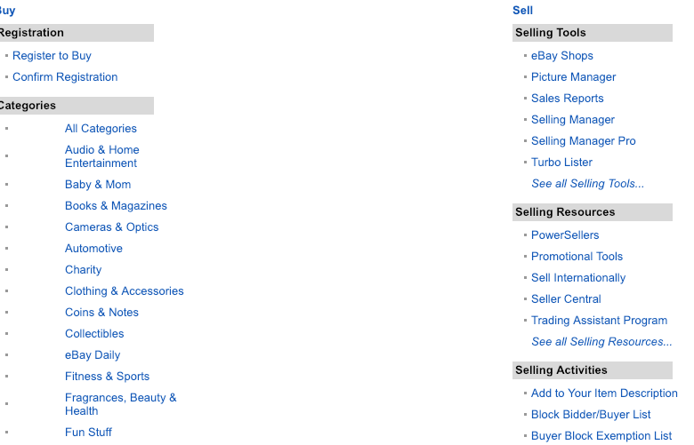
Sample XML Sitemap:
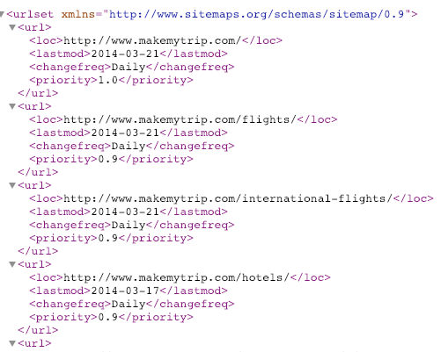
TIP: 👍
- Automatic sitemap generator: https://www.xml-sitemaps.com/
- Most of the wordpress plugins will have this feature
ACTION ITEM: ✓
- Create an XML sitemap and submit to Google search console
- Check for broken links and update the site map

SECTION 15. Optimize for Voice Search
Most of the answers from Google assistant/voice search comes from featured snippets or position 0 or Answer box. Understanding schema with authoritative content can help.
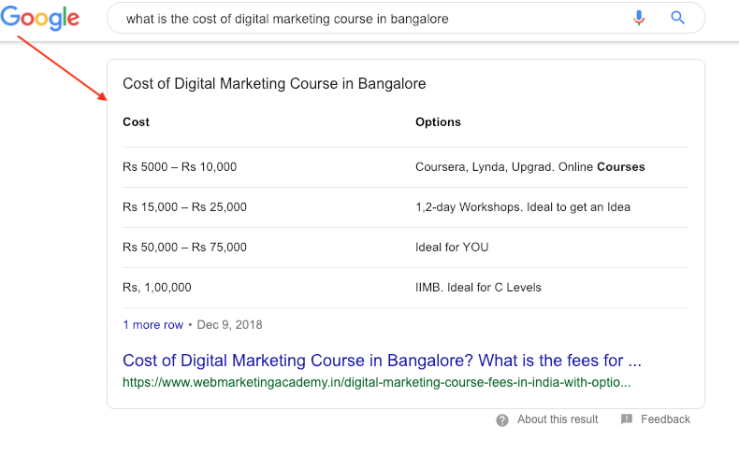
TIP: 👍
- Learn how to structure your data: https://schema.org/ https://developers.google.com/search/docs/guides/search-gallery
- Watch this video on how to get into Answer box: https://www.youtube.com/watch?v=gjFc_vdvDyI
ACTION ITEM: ✓
- Include schema markup for all content including articles, blogs
- Update the web pages with relevant structured data

SECTION 16. Structured Data/Schema.org
Structured data is a standardized format for providing information about your page and classifying the page content; for example, on a recipe page, what are the ingredients, the cooking time and temperature, the calories.
Google uses structured data that finds from your website. Structured data can be used for
- Business details
- Reviews
- Local business listings
- Videos
- Podcast
- Blogs/articles
- How to’s
- FAQ’s
Example of FAQ structured data
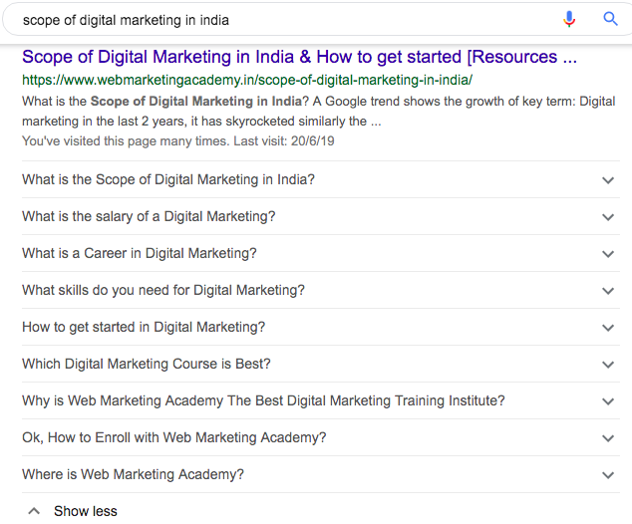
TIP: 👍
- A detailed guide on structured data: https://developers.google.com/search/docs/guides/intro-structured-data
- A complete list of schema markup: https://schema.org/Intangible
ACTION ITEM: ✓
- Mark up all your pages with structured data
- Validate your pages with Google structured data testing tool. https://search.google.com/structured-data/testing-tool/u/0/
Resource: A step by step guide on how to structure your data: http://bit.ly/2YtSeEJ

SECTION 17. Claim your Google my business listings
Google my business if another free tool by Google for any business. If you are local business get your business listed in Google. You have to update the listings and get verified.
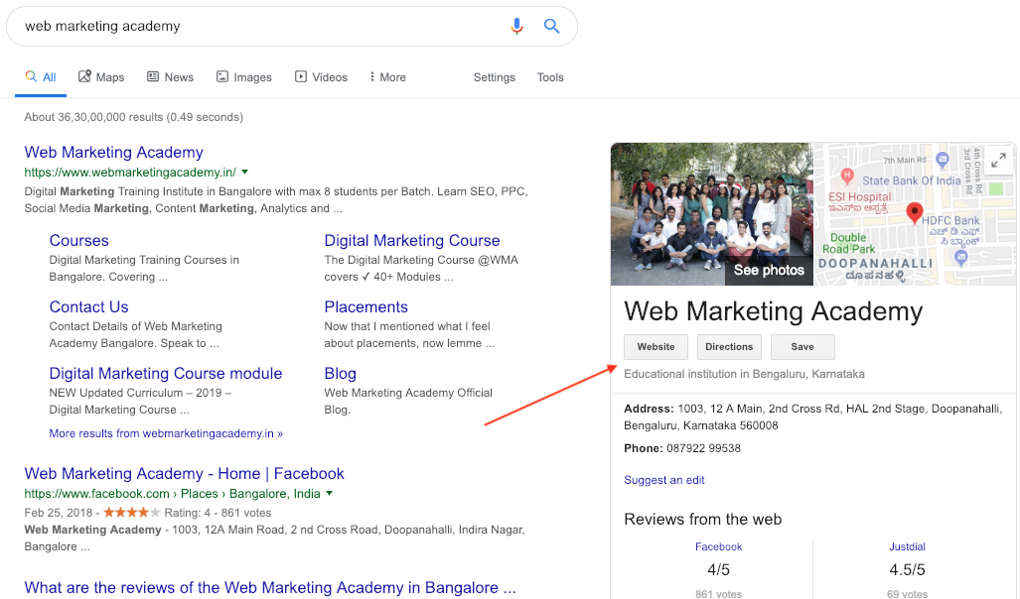
TIP: 👍
- Update your Google my business listing with products, services, events, offers
- Upload images, videos
- Ask for customer reviews and testimonials
- Google posts has got new features like adding products, events etc
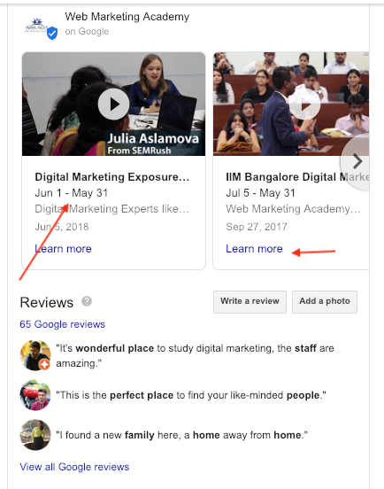
ACTION ITEM: ✓
- Create new posts with videos, update offers, showcase product
- Add multiple categories

SECTION 18. Universal SEO
Universal search or blended search. When you do a Google search you get a combination of web pages, images, videos, social media. Optimizing all of your properties including You Tube, Slide share, social media can help Google show rich results in SERP for your brand

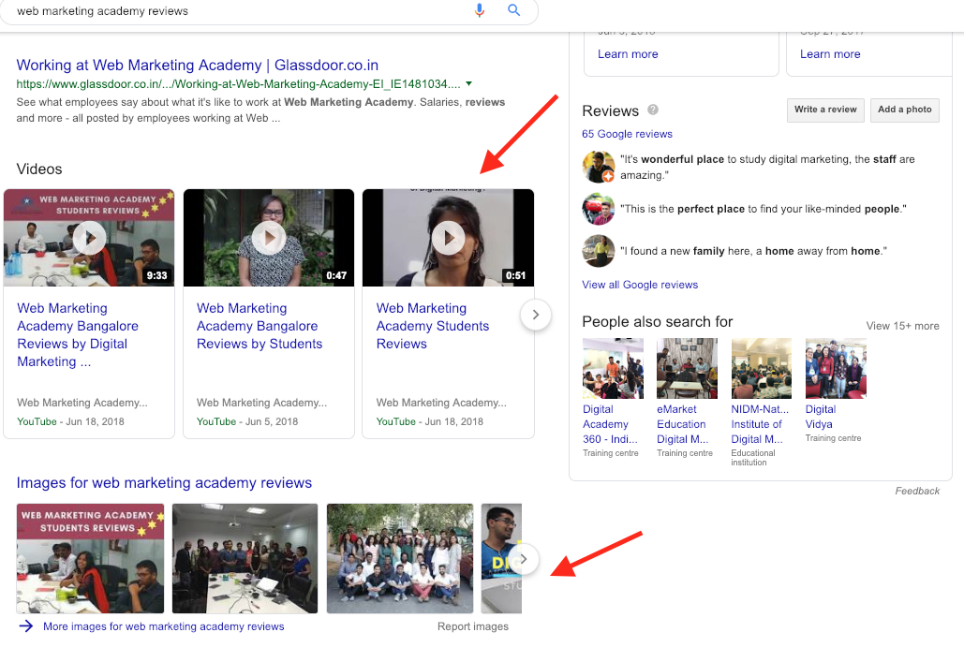
TIP: 👍
- Optimize your videos in You Tube (same SEO techniques applies for YouTube. Keywords, Title, Description, Category and Tags)
- All other multimedia platforms including LinkedIn, Twitter, PInterest allows you to optimize your content
ACTION ITEM: ✓
- Create accounts/optimize all social media channels and get the basics right
- Give links from social media channels to your website

SECTION 19. Off page SEO
Off page SEO is about getting links from other websites to your website. Backlinks. If your content is valuable, others will give a link to your website. Off page is a longer process unlike on page SEO
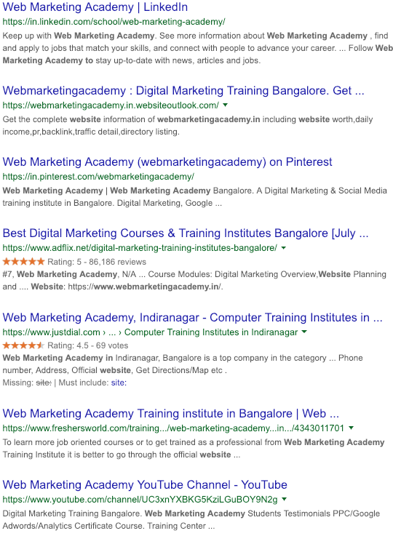

TIP: 👍
- Learn all about off page SEO here: https://ahrefs.com/blog/off-page-seo/
- Create valuable content where others can share
- Write useful answers on Quora, if you have the resources in your website for further reference, give a link to your website
ACTION ITEM: ✓
- Come up with a list of blog post topics, useful articles to write, distribute
- Come up with an infographic or image for interesting, useful articles to upload in Pinterest and give a link from Pinterest to this specific article

Hope you find this guide useful. Please feel free to share it, download it
My Contact details:
Email: suresh@webmarketingacademy.in
Instagram: https://www.instagram.com/webmarketingacademy/
Phone: 8792299538

